[Skip to main content](http://www.rajalakshmicolleges.org/moodle/mod/quiz/review.php" \l "maincontent)

REC-CIS

GE23131-Programming Using C-2024

|  |  |
| --- | --- |
| **Status** | Finished |
| **Started** | Saturday, 29 December 2024, 11:21 PM |
| **Completed** | Saturday, 29 December 2024, 11:31 PM |
| **Duration** | 9 mins 25 secs |

Top of Form

Question **1**

Correct

Marked out of 1.00

Flag question

Question text

A binary number is a combination of 1s and 0s. Its nth least significant digit is the nth digit starting from the right starting with 1. Given a decimal number, convert it to binary and determine the value of the the 4th least significant digit.

**Example**

number = 23

·         Convert the decimal number 23 to binary number: 2310 = 24 + 22 + 21 + 20    = (10111)2.

·         The value of the 4th index from the right in the binary representation is 0.

**Function Description**

Complete the function fourthBit in the editor below.

fourthBit has the following parameter(s):

int number:  a decimal integer

Returns:

int: an integer 0 or 1 matching the 4th least significant digit in the binary representation of number.

**Constraints**

0 ≤ number < 231

**Input Format for Custom Testing**

Input from stdin will be processed as follows and passed to the function.

The only line contains an integer, number.

**Sample Case 0**

**Sample Input 0**

STDIN  Function

-----  --------

32   → number = 32

**Sample Output 0**

0

**Explanation 0**

·         Convert the decimal number 32 to binary number: 3210 = (100000)2.

·         The value of the 4th index from the right in the binary representation is 0.

**Sample Case 1**

**Sample Input 1**

STDIN   Function

-----   --------

77   →  number = 77

**Sample Output 1**

1

**Explanation 1**

·         Convert the decimal number 77 to binary number: 7710 = (1001101)2.

·         The value of the 4th index from the right in the binary representation is 1.

Answer:(penalty regime: 0 %)

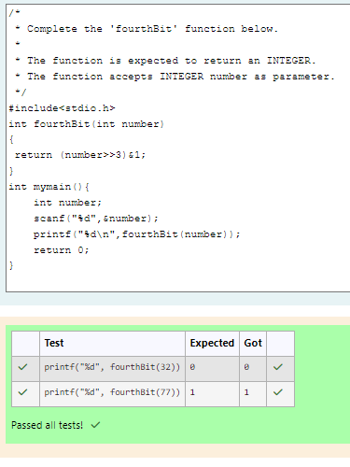

Feedback

|  | **Test** | **Expected** | **Got** |  |
| --- | --- | --- | --- | --- |
|  | printf("%d", fourthBit(32)) | 0 | 0 |  |
|  | printf("%d", fourthBit(77)) | 1 | 1 |  |

Passed all tests!

Question **2**

Correct

Marked out of 1.00

Flag question

Question text

Determine the factors of a number (i.e., all positive integer values that evenly divide into a number) and then return the pth element of the list, sorted ascending. If there is no pth element, return 0.

**Example**

n = 20

p = 3

The factors of 20 in ascending order are {1, 2, 4, 5, 10, 20}. Using 1-based indexing, if p = 3, then 4 is returned. If p > 6, 0 would be returned.

**Function Description**

Complete the function pthFactor in the editor below.

pthFactor has the following parameter(s):

int n:  the integer whose factors are to be found

int p:  the index of the factor to be returned

Returns:

int: the long integer value of the pth integer factor of n or, if there is no factor at that index, then 0 is returned

**Constraints**

1 ≤ n ≤ 1015

1 ≤ p ≤ 109

Input Format for Custom Testing

Input from stdin will be processed as follows and passed to the function.

The first line contains an integer n, the number to factor.

The second line contains an integer p, the 1-based index of the factor to return.

**Sample Case 0**

**Sample Input 0**

STDIN      Function

-----      --------

10     →   n = 10

3      →   p = 3

**Sample Output 0**

5

**Explanation 0**

Factoring n = 10 results in {1, 2, 5, 10}. Return the p = 3rd factor, 5, as the answer.

**Sample Case 1**

**Sample Input 1**

STDIN      Function

-----      --------

10     →   n = 10

5      →   p = 5

**Sample Output 1**

0

**Explanation 1**

Factoring n = 10 results in {1, 2, 5, 10}. There are only 4 factors and p = 5, therefore 0 is returned as the answer.

**Sample Case 2**

**Sample Input 2**

STDIN      Function

-----      --------

1     →   n = 1

1     →   p = 1

**Sample Output 2**

1

**Explanation 2**

Factoring n = 1 results in {1}. The p = 1st factor of 1 is returned as the answer.

Answer:(penalty regime: 0 %)

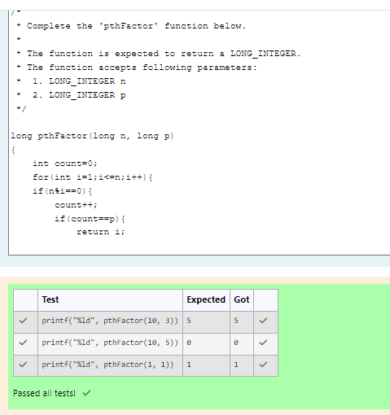

Feedback

|  | **Test** | **Expected** | **Got** |  |
| --- | --- | --- | --- | --- |
|  | printf("%ld", pthFactor(10, 3)) | 5 | 5 |  |
|  | printf("%ld", pthFactor(10, 5)) | 0 | 0 |  |
|  | printf("%ld", pthFactor(1, 1)) | 1 | 1 |  |

Passed all tests!

Bottom of Form

Blocks

[Skip Quiz navigation](http://www.rajalakshmicolleges.org/moodle/mod/quiz/review.php#sb-1)

Quiz navigation

[Question1This page](http://www.rajalakshmicolleges.org/moodle/mod/quiz/review.php#question-153637-1)[Question2This page](http://www.rajalakshmicolleges.org/moodle/mod/quiz/review.php#question-153637-2)

[Show one page at a time](http://www.rajalakshmicolleges.org/moodle/mod/quiz/review.php?attempt=153375&cmid=194&showall=0)

Blocks